Physical Foundations for Early Writing

Wiggle Me into Squiggle & Squiggle Whilst You Wiggle
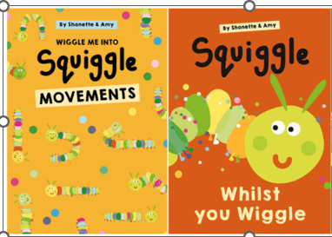

Key features
- A progressive physical development approach that supports children to develop the gross motor skills, fine motor skills and core strength needed for early mark making and writing.
- Children use movement, music and mark making to strengthen muscles, develop coordination and build the physical control needed for later handwriting.
- The approach supports children to develop confidence, rhythm, bilateral coordination, crossing the midline, shoulder stability, wrist control and finger strength.
- Formal letter formation is taught through the school’s chosen SSP handwriting programme when children are developmentally ready.
Progression through the Programme
From the age of two, children begin their physical journey towards writing through Wiggle Me into Squiggle. This movement-based programme develops the gross motor skills, core strength, balance, coordination and bilateral movements that underpin successful mark making and later handwriting.
As children's physical development progresses, they move on to Squiggle Whilst You Wiggle. Through dance, music and purposeful movement, children learn a series of large movement patterns before transferring these to meaningful mark making using a range of tools and media. This approach helps children develop shoulder stability, wrist control, finger strength and confidence as emerging writers.
Sessions combine movement with purposeful opportunities for children to make meaningful marks, gradually strengthening the physical skills needed for writing while fostering creativity, enjoyment and independence.
As children enter Reception, Squiggle Whilst You Wiggle continues to develop the physical skills that underpin successful handwriting. Alongside the school's chosen systematic synthetic phonics and handwriting programme, children continue to strengthen their coordination, control and fluency while learning to form letters correctly and write with increasing confidence.

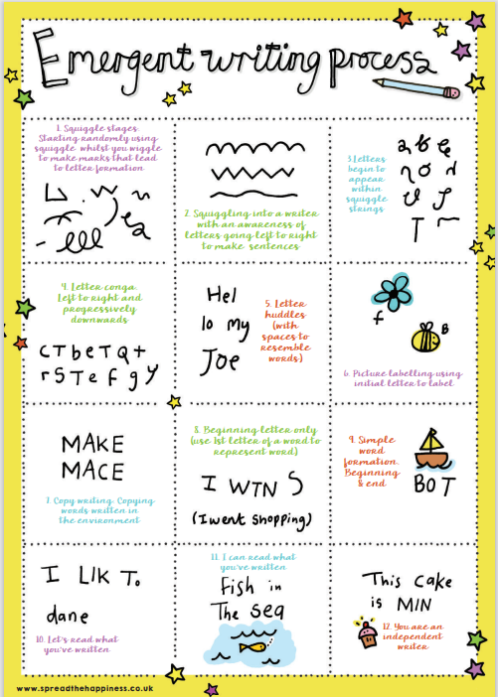

Stage 1 Wiggle Me into Squiggle
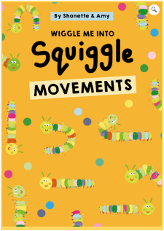 | Wiggle Me into Squiggle  - Typically Delivered within the 2-year-old provision and/or Nursery (3–4 years), according to children's developmental stage and individual needs.  - A movement-based programme that supports the physical foundations for writing by developing gross motor skills, core strength, balance, coordination and bilateral movement patterns.  - Designed to strengthen the physical skills that underpin successful mark making and handwriting, while supporting children to revisit and embed key developmental movement patterns where needed.  - Delivered through daily 10-minute adult-led sessions, followed by opportunities to revisit and apply the focus movement through continuous provision and enhanced activities.  - Each movement is typically taught over one week. Practitioners should use ongoing assessment to determine whether children would benefit from additional practice before moving on.  - Sessions begin with the Wiggle Song, followed by the focus movement using flipper flappers to encourage large, coordinated bilateral movements.  - Children should have regular opportunities to revisit the focus movement through a range of purposeful sensory, creative and continuous provision experiences, enabling them to transfer gross motor movements into meaningful mark making.

Wiggle progression:
Week | Movement | Song
1 | Movement 1: Up | The Only Way is Up by Jazz
2 | Movement 2: down | The Grand Old Duke of York
3 | Movement 3: Circles | You Spin Me Round by Dead or Alive
4 | Movement 4: Wiggle it! | Wriggle by Cosmo Sheldrake
5 | Movement 5: Shake | Shake, Shark, Shake Senora by Harry Belafonte
6 | Movement 6: Hop Hoppity Hop | Hop Little Bunnies
7 | Movement 7: Jump, Jump, Jump! | Jump (for my love) by The Pointer Sisters
8 | Movement 8: Turning Turtle | Firework by Katie Perry
9 | Movement 9: Flip and roll | n/a
10 | Movement 10: Crawl | n/a

Stage 2 Squiggle Whilst you Wiggle
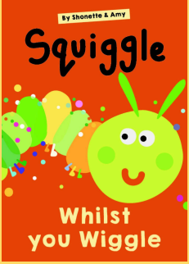 | - Builds on the physical skills developed through Wiggle Me into Squiggle, introducing nine progressive movement patterns that support increasingly controlled and purposeful mark making.  - Continues to develop both gross and fine motor control through movement, music and mark making, strengthening the physical foundations needed for efficient handwriting.  - Sessions combine large-scale movement with opportunities to transfer movement patterns into purposeful mark making, helping children develop shoulder stability, wrist control, finger strength and bilateral coordination.  - Delivered through 10–15 minute adult-led sessions, followed by opportunities to revisit and apply the focus movement pattern through continuous provision and enhanced activities.  - Uses music and flipper flappers to encourage coordinated bilateral movements and support children's physical development.  - In Nursery, sessions should ideally take place daily. Where this is not possible, a minimum of three to four sessions each week is recommended.  - Can be delivered alongside other physical development approaches, such as Dough Disco, as part of a balanced programme to develop the physical skills needed for writing.  - Each movement pattern is typically taught over three weeks, allowing children sufficient time to embed both the gross motor movement and the associated mark-making pattern.  - Practitioners should use ongoing assessment to provide additional support where needed. If children are finding a movement pattern challenging, move on after three weeks and revisit it later, rather than extending the programme indefinitely.

Squiggle progression:
Weeks | Move/dance
1-3 | Move 1: Up and down, side to side, cross over
4-6 | Move 2: The wiggle
7-9 | Move 3: The circle
10-12 | Move 4: The hump and Move 4 (part 2): The under hump
13-15 | Move 5: The hook
16-18 | Move 6: The spiral
19-21 | Move 7: The wave
22-24 | Move 8: Laid down 8 (then stand me up straight!)
25-27 | Move 9: The straight line

Suggested Progression Across a Nursery Year
 | Autumn 1 | Autumn 2 | Spring 1 | Spring 2 | Summer 1 | Summer 2
Physical Foundations for Early Writing | Wiggle me into Squiggle  1 move per week (Weeks 1-6) | Wiggle me into Squiggle  1 move per week (Weeks 7-10)  Squiggle While you Wiggle 2.0-  Move 1 (3 weeks) | Squiggle While you Wiggle 2.0-  Move 2 (3 weeks)  Squiggle While you Wiggle 2.0-  Move 3 (3 weeks) | Squiggle While you Wiggle 2.0-  Move 4 (3 weeks)  Squiggle While you Wiggle 2.0-  Move 5 (3 weeks) | Squiggle While you Wiggle 2.0-  Move 6 (3 weeks)  Squiggle While you Wiggle 2.0-  Move 7 (3 weeks) | Squiggle While you Wiggle 2.0-  Move 8 (3 weeks)  Squiggle While you Wiggle 2.0-  Move 9 (3 weeks)

Suggested Progression Across a Reception Year
 | Autumn 1 | Autumn 2 | Spring 1 | Spring 2 | Summer 1 | Summer 2
Physical Foundations for Early Writing | Squiggle While you Wiggle 2.0-  Recap one move per week | Squiggle While you Wiggle 2.0-  Recap one move per week | Squiggle While you Wiggle 2.0-  Recap one move per week | Squiggle While you Wiggle 2.0-  Recap one move per week | Squiggle While you Wiggle 2.0-  Recap one move per week | Squiggle While you Wiggle 2.0-  Recap one move per week
Little Wandle Handwriting session | Focus on patterns through Squiggle sessions | Single lower-case letter formation in letter families | Single lower-case letter formation in letter families | Capital letter formation, recap of single lower-case letter formation | Capital letter formation, recap of single lower-case letter formation | Teach letter formation within digraphs & trigraphs
The timings above are intended as a guide and should be adapted according to children's developmental needs and ongoing assessment.

Role of the adults
- Observe children's physical development and adapt teaching accordingly.
- Model movement patterns enthusiastically.
- Celebrate effort and perseverance.
- Provide daily opportunities for meaningful mark making.
- Ensure experiences remain playful and engaging.
- Work in partnership with families to support physical development for writing.

