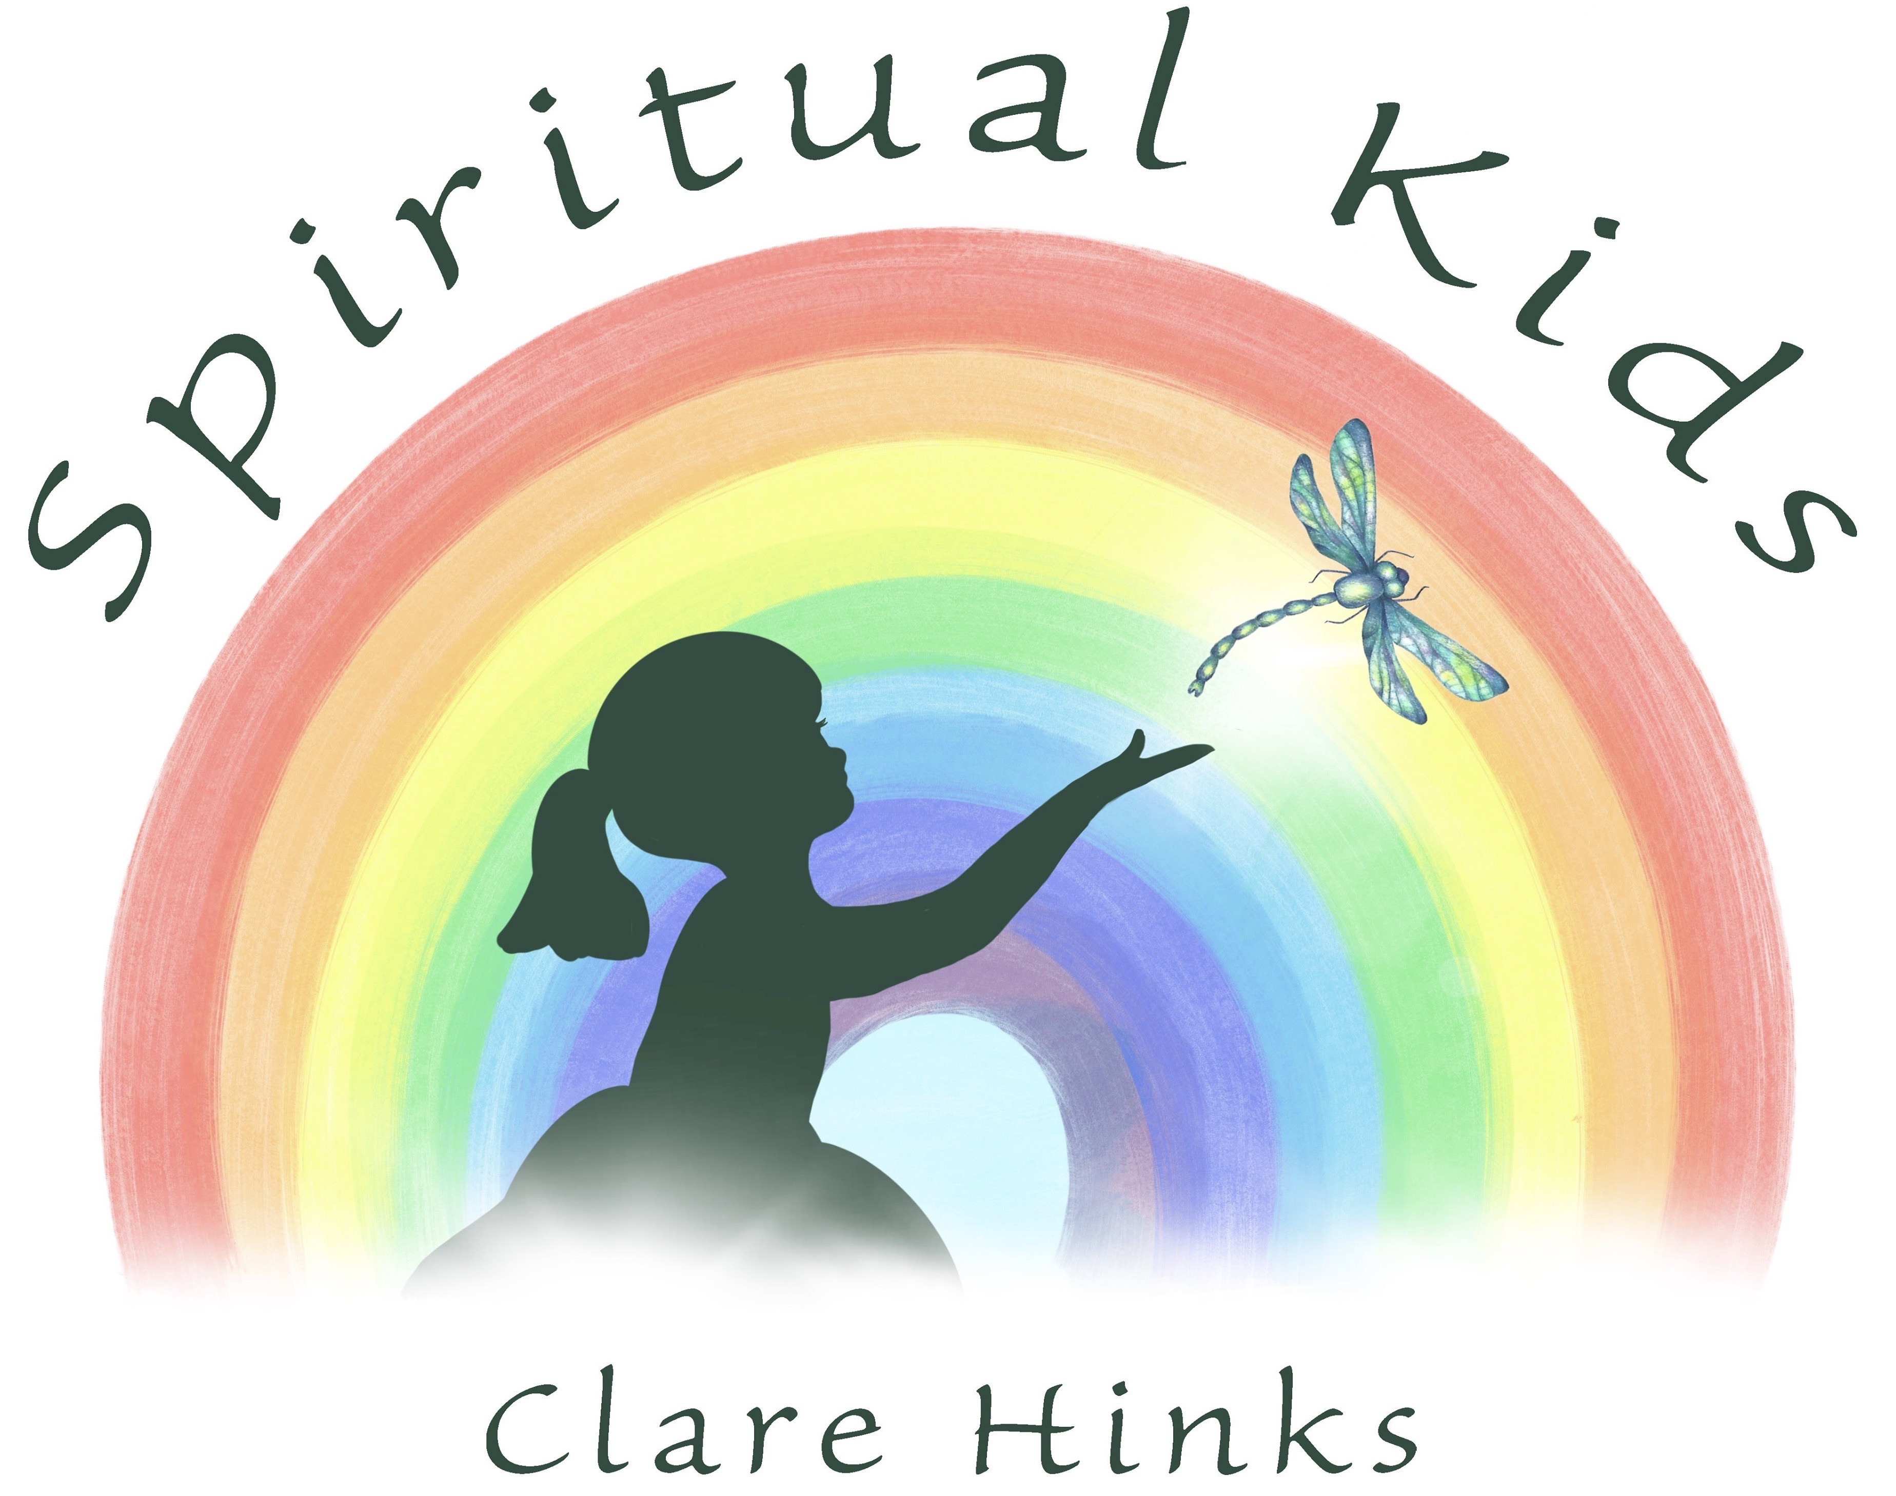

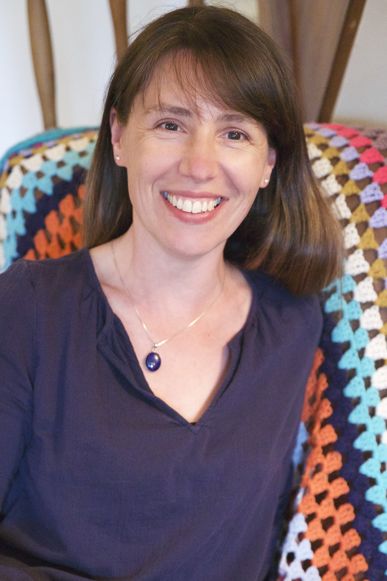

Welcome to Spiritual Kids……. Offering Meditation & Mindfulness in our children and young people.

Hello, I would like to introduce myself.
I am Clare Hinks, I’m the founder of Spiritual Kids and I’m excited to offer some meditation & mindfulness to your school.

I have been practicing meditation myself every day for the last 3 years and can absolutely tell you it has changed my life. Daily mindfulness has an enormous amount of benefits, not only for our minds, but also physically. Recorded benefits are such as lowering blood pressure, thinking clearly, increased focus and concentration to name but a few.
As well as helping us to gain control over feelings of anxiety, worry or stress.

All of the above are becoming more common in our children, so my aim is to bring them some easy ways to “feel” better , whilst understanding that our thoughts create our feelings.
I have explained below what the sessions involve and how I hope the chidden will benefit.

During our sessions together we will have some circle time, share some things that make us happy and use our imaginations to help us understand our how our minds work and what makes us feel happy.
The sessions are fun and relaxed & aim to raise an awareness in children to help them deal with and understand the power and control they have over themselves.

I have a passion for helping people live their best life & have completed diplomas in Meditation, Children’s meditation, and a teaching meditation diploma.
I have previously worked with children in nursery, preschool and school, and have 3 of my own children.
It is my absolute pleasure to have created Spiritual Kids and to have the opportunity to share this with you and your children.

Blessings

Clare

clarehinksmedium.com/kids

Call- 07552733088

Clarehinksmedium@gmail.com

